

Computing Project

Project Specifications

Muhammad Khan

Supervisor

Matthew Hoban

Table of Contents

Work overview 2

Technologies and Materials 3

Motivation research 3

Existing knowledge 3

New knowledge 3

Timeline and milestones 3

Project repository address 4

# **Work overview**

I am planning to implement a business management system for the business crewing industry. The application will allow the business managers/owners to register their new and existing employees by adding their details to the database such as name, address, email address, date of birth, phone number, UTR and hourly rate to the database. Whenever the owner/manager get a new job from the client, they will fill in the job detail form with the details such as job venue, time, date and how many hour the shift is and select who is available on that day to do the shift and send it off to them. Once the form has been submitted, the staff to who is available will get a text on their phone asking them if they can do that job, the staff will reply with a Yes or No.

If the employee replies with a yes, they will be automatically added on that shift and manager will be notified, the job has been accepted. The person who has accepted the job their name will be highlight in green, and it will be added to their calendar and his name will not appear for another shift on the same day and time to avoid double booking. If a specific job requires more then one crew, it can be done in a same way by selecting their names and send it to all of them at once. The employees will reply to the text with a yes or no, if one of them is not available and reply to the text with no, the manager will be notified, and he will be able to send it off to someone else.

However, if the employee is not available to the do the job, they will be able to reply No to the text along with a reason why they can do it. The manager will be notified, the manager will be able to send it off to someone else.

The staff that has accepted the job, they will get an automatic job confirmation 2 days before the shift, the job confirmation will include job details such as job venue, time date and contact number and list of crew that is on that job along with contact numbers of the supervisor.

The application will automatically create a time sheet for the crew, and it will be automatically emailed to them at the end of the month, the sheet will have all the jobs details they have done, once they have received the time sheet and have checked all the hours, they can reply to email by sending their invoice.

The system will also allow the managers to have their own username and password. For them to use any of the features they have login to them system. There will be different level of access for the staff and the mangers, the managers will be able to access every feature, such as company monthly reports etc whereas as the crew will only be able to access calendar.

When the crew logins they will be able to see a calendar, which will show what day and time they are working, and detail about the job.

# **Technologies and Materials**

The languages I am going to build it will be html, CSS and java script for the front end and for the back end I will use php, mongo DB or MySQL and google libraries such as jQuery. I am going to be using different libraries, one of them is bootstrap, ratched and responsive boilerplate libraries and php library.

The equipment’s I will need are laptop, or an android/iPhone phone and access to the internet. I have already purchased a laptop for my university assignments, which I will used to implement it and I also have access to an android phone.

# **Motivation research**

My cousin work in crewing industry, and he run a business crew company where he provides crew to companies that need crew for specific events for setup and derigs. I interviewed him and I also had interview with others crewing company. They currently use text messaging. When every they get any job they call their crew or send them a text message from their phone asking them if they are available to work and waits for their reply and if the staff say yes them they use calendars such as google calendar <https://calendar.google.com/calendar/r> to make a note of it, then day before a job, they manually write text with the job details and sends to the person who on shift.

And the crew manually makes the note of the job using calendars or third-party apps such as notes.

# **Existing knowledge**

In my first of studies I did one of them module called web development, where I learned about html and JavaScript and CSS. In my second year I learned we did algorithms, where I learned about different algorithms and I also did data and the web, where I learned about databases and how to use different libraries,

# **New knowledge**

I have never done any programming with php before, I have learn php and to learn php, I will do some online courses on sites such as <https://www.codecademy.com/learn/learn-php> and I will be watching some YouTube tutorials such as <https://www.youtube.com/watch?v=OK_JCtrrv-c>.

# **Timeline and milestones**

I will need to conduct more interviews with other bigger crew companies that are well established that might be using similar system to gain better understanding of their current system and check what issues they currently having with existing system and how can it be further improved.

I will also conduct interviews with the crew to see what other features they would want on the system other than calendar.

My minimum viable product will be to create a login, which will allow the user to login to them system, and implement backend and frontend which will allow the manger to send text to crew and the crew should be able to response with yes or no, this is my minimum viable product.

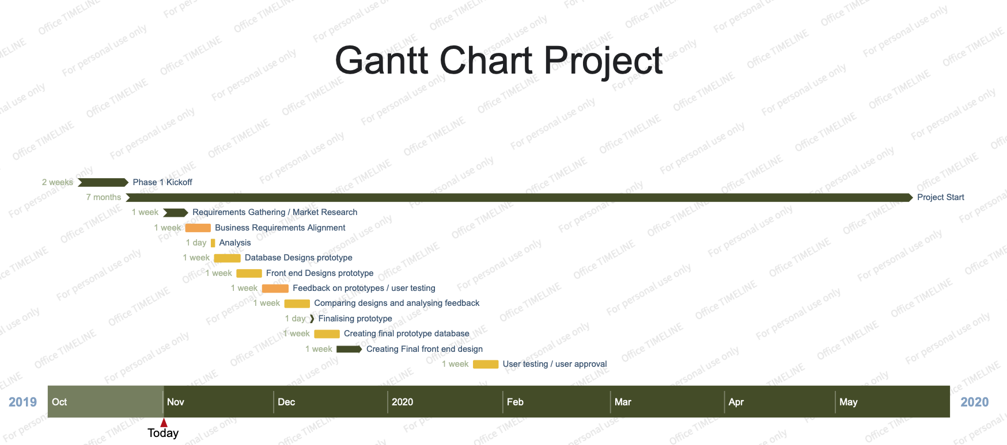

# **Project repository address**

<https://github.com/mkhan012/ComputingProject.git>